Nama : Aldias Ibnu Habib

NIM : L200170166

Kelas : E

**Praktikum Data Warehouse Data Mining**

**---**

Menggunakan Operator Fuzzy K-Means dengan dataset Modul 10

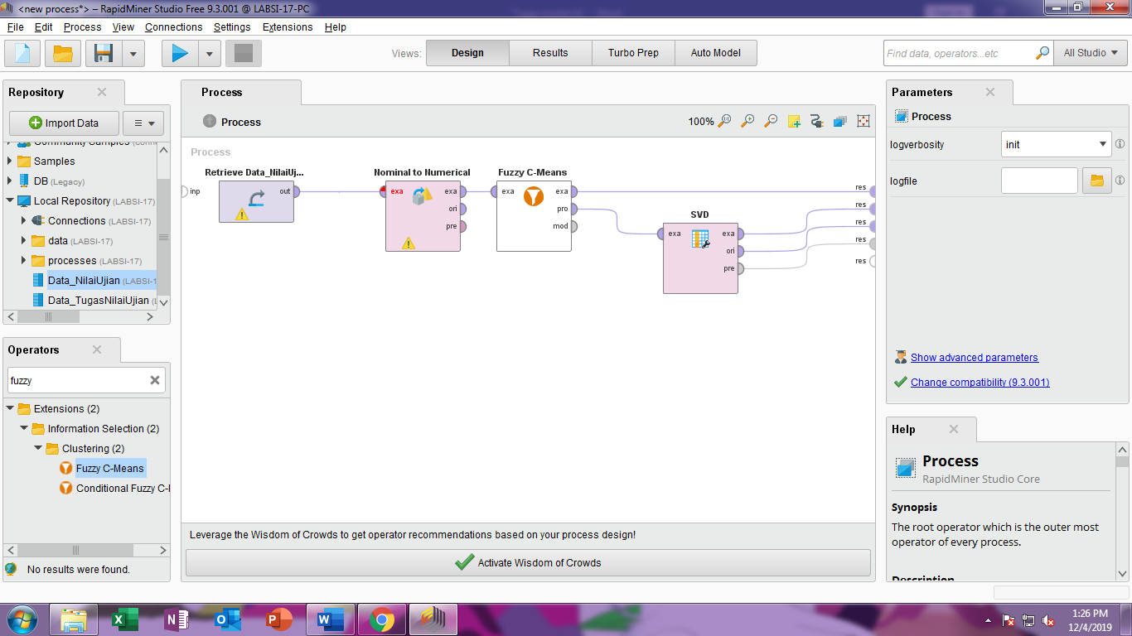

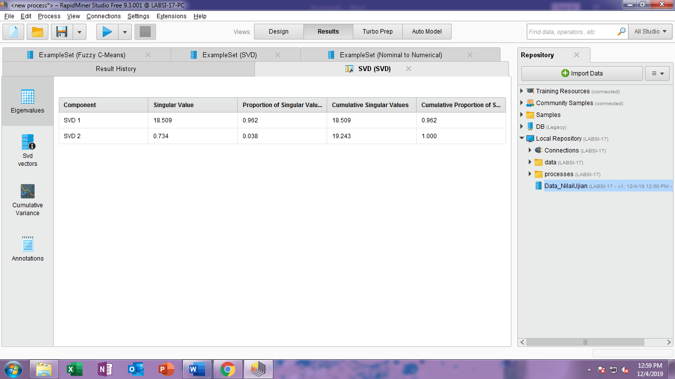

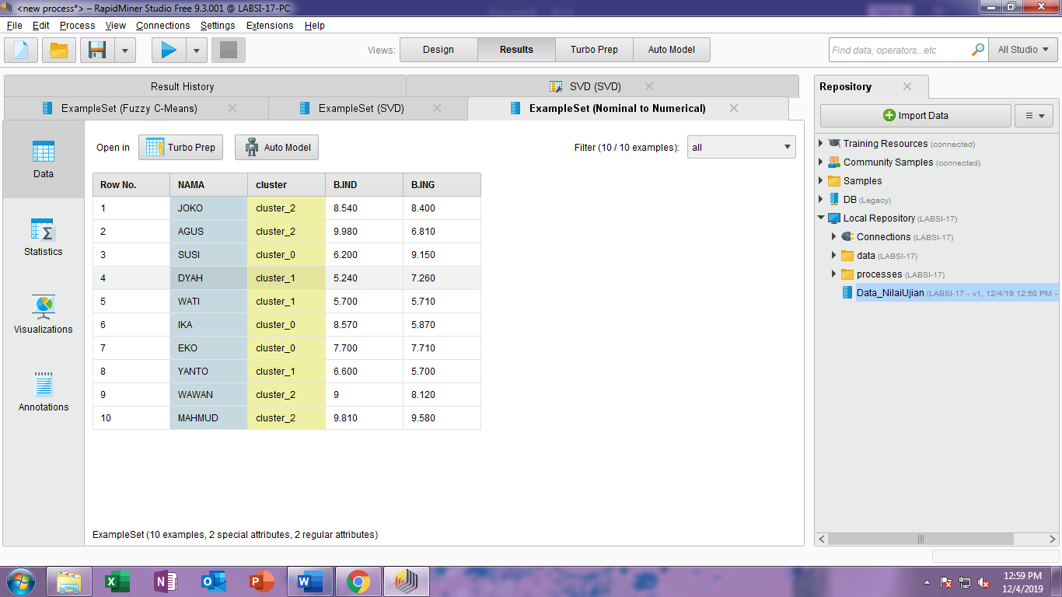

Latihan dengan menggunakan model K-Means Clustering seperti berikut

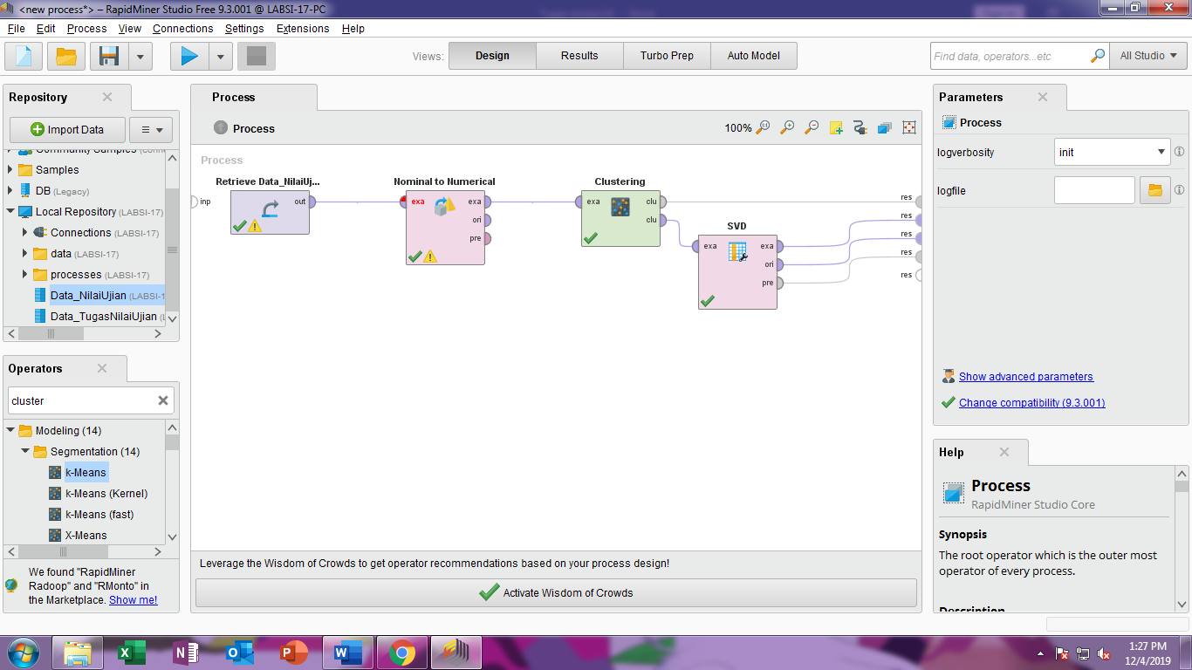

Hasilnya setelah dijalankan seperti ini SVD

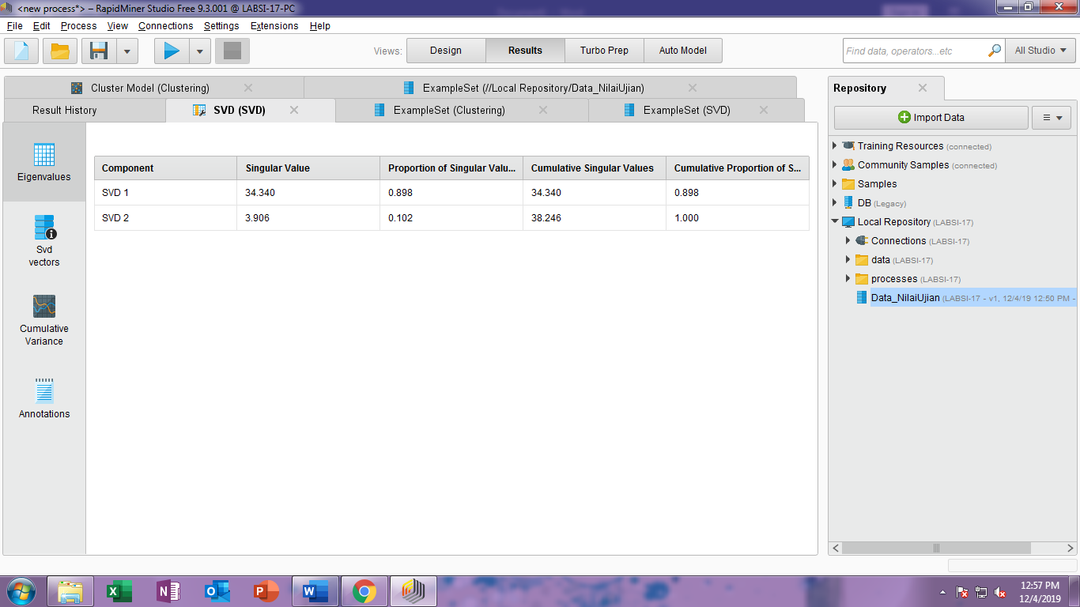

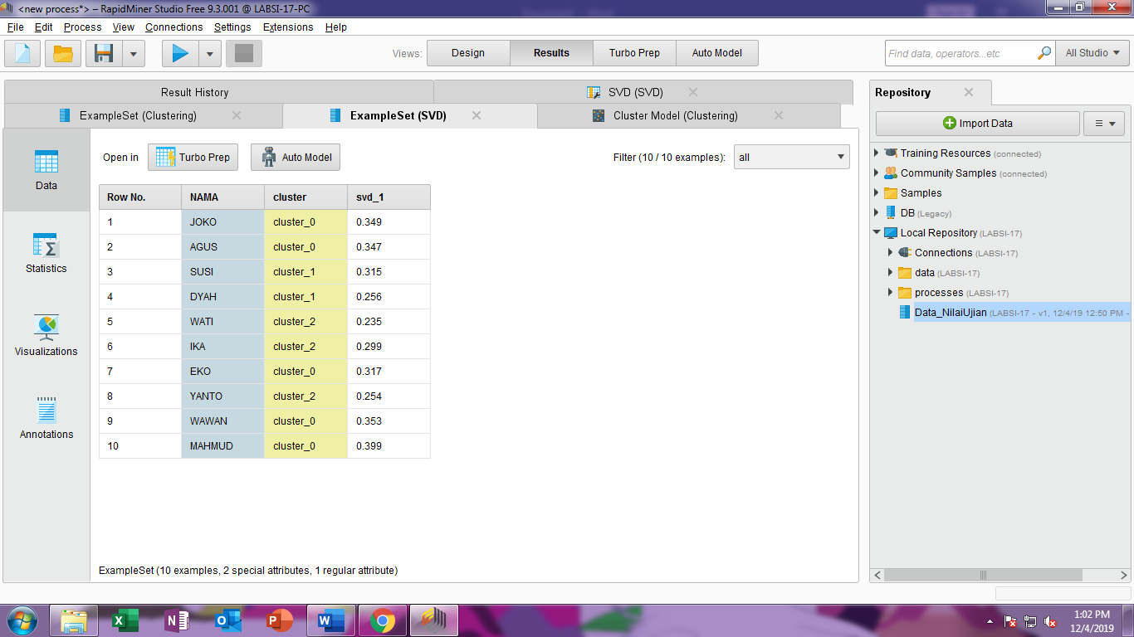

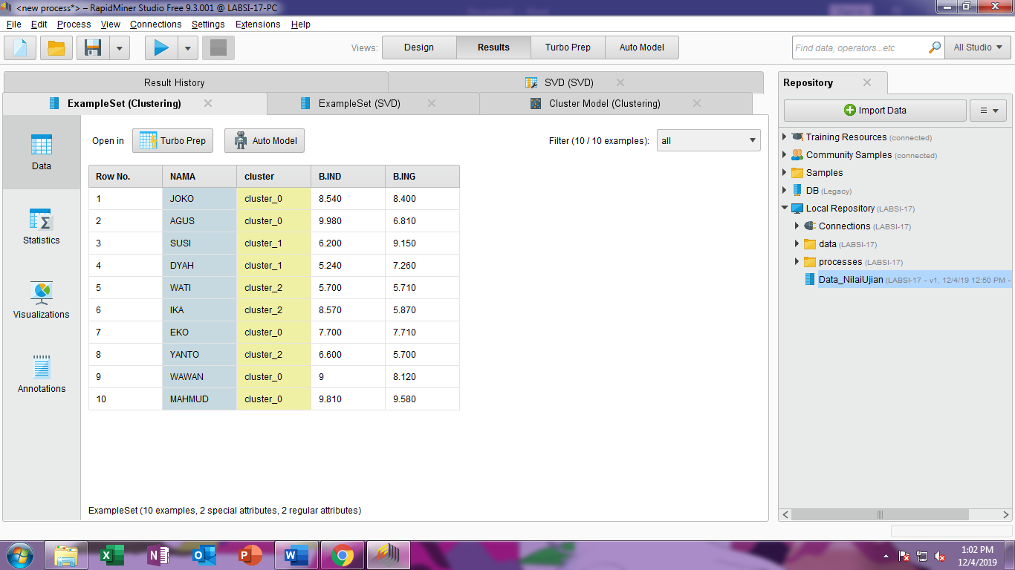

Tugas modul 1-3 dengan mengganti operator K-Means menjadi Fuzzy K-Means

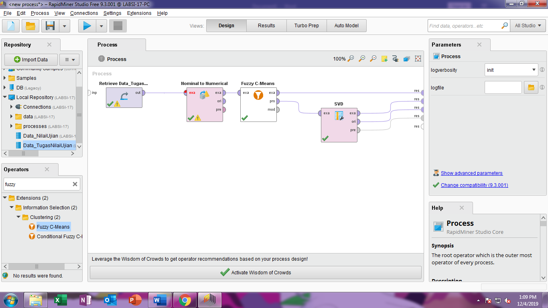

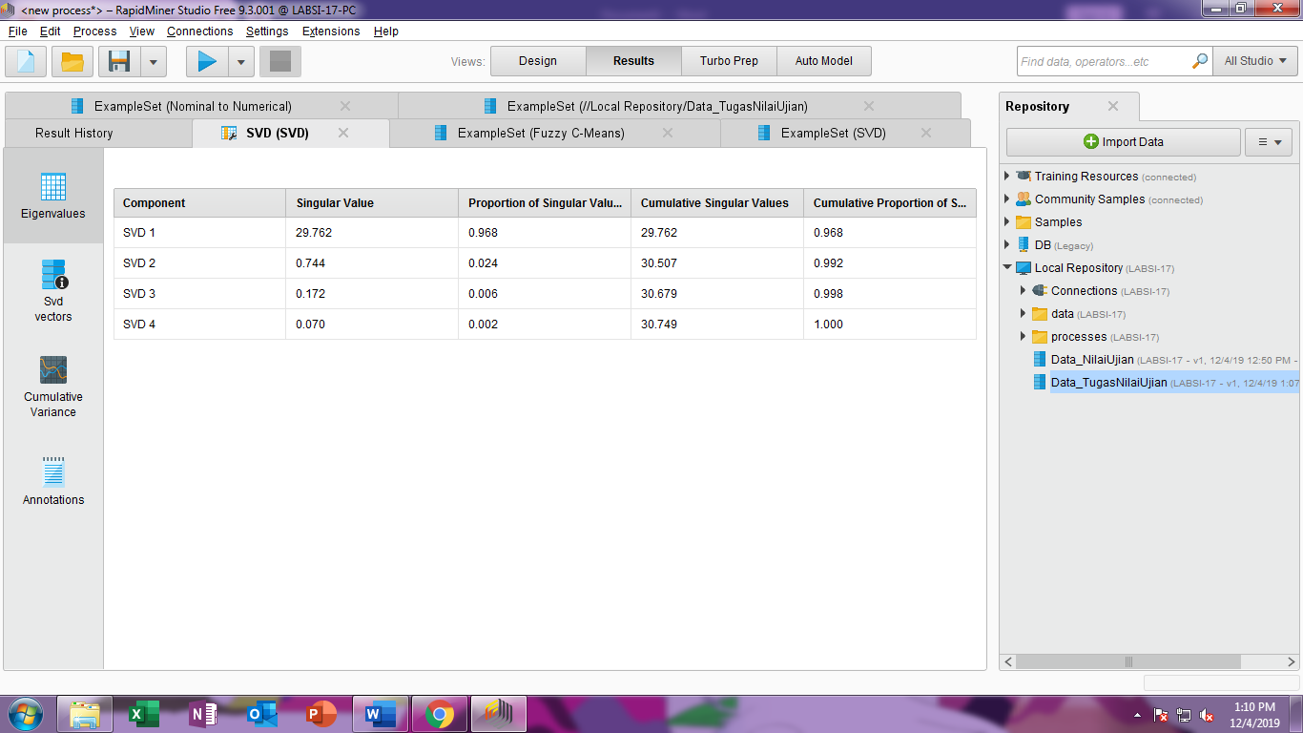

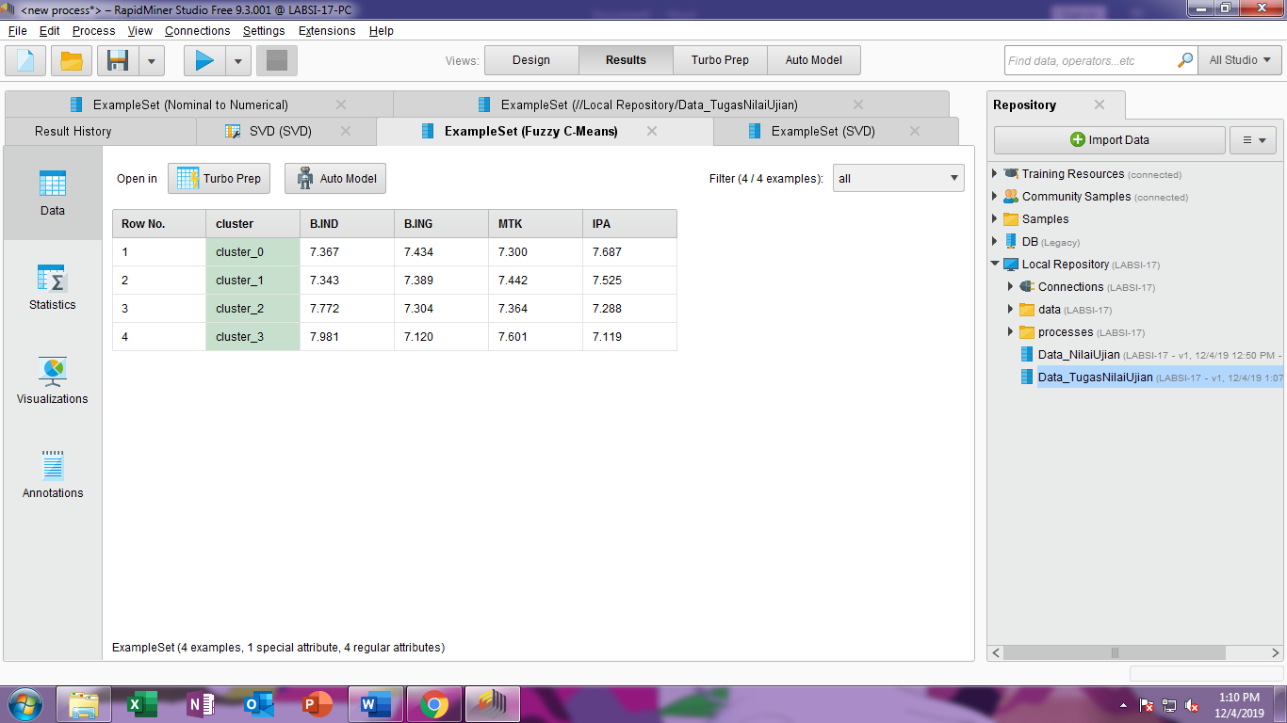

**Row Nama Cluster Bind Bing MTK IPA**

1 JOKO cluster_0 6.603538097606661 9.988531846947591 9.40671786806273 8.946786181069637

2 AGUS cluster_1 5.2256780668097 8.470577786145704 8.193652358843575 5.949773861207854

3 SUSI cluster_0 5.889308498689421 5.478128059406203 7.833826378637742 9.213126439836769

4 DYAH cluster_1 5.695602836372499 7.912175937003151 9.64894505401519 7.779247701270701

5 WATI cluster_3 9.24519827471445 8.580605950365175 9.669600424196997 7.40875078536469

6 IKA cluster_2 9.167996505566965 8.415261447786083 6.201668146451432 8.024068811373652

7 EKO cluster_3 9.763598391108973 7.155680109727502 7.415249814149046 5.774657816751888

8 YANTO cluster_0 6.127627204170479 9.7592772633671 6.822330131082485 9.022510369911132

9 WAWAN cluster_3 7.779634345382367 5.2585481960998095 6.496835700884094 6.789498853137804

10 MAHMUD cluster_0 6.365355926720444 9.449476687829058 5.303099595582703 7.410728551681112

11 BUDI cluster_2 7.126052685398463 7.050707563617511 6.3778844623720135 5.966279166694744

12 SANTI cluster_3 9.427853316159833 7.555590144928474 8.46002211396074 5.163907092090889

13 DIAN cluster_3 9.267606920164267 6.627750605906689 9.150032680052512 7.585076045413279

14 DANI cluster_0 5.9768349154737646 6.714961222124876 7.099378638333757 8.711643555490404

15 AHMAD cluster_0 6.837629204675098 7.79547826200358 5.330240500484848 9.103831403766176

16 BAYU cluster_3 9.646574565196616 5.3201066300203355 6.505155015445394 5.5889732191127734

17 RISA cluster_0 6.7521123542608645 5.136600905960794 6.070545701333531 7.721629779252126

18 RANI cluster_3 8.680995507313463 6.08770858737879 9.064714774320066 5.939253658587756

19 YANI cluster_3 9.736770462971748 7.179764506702464 7.362299136312747 5.736744052458802

20 RATIH cluster_0 7.988549962578902 6.992174689044175 6.726133940453282 8.159293608069179

21 INDAH cluster_0 7.1428632462666215 9.181339266497194 6.959070108222858 9.509064956207098

22 JONO cluster_3 8.61427410002014 5.6798096907943485 8.681473605515952 7.2934680711717075

23 SARAH cluster_2 8.046781239723499 8.334938559315262 7.127997079920038 6.824924478193858

24 RAMA cluster_2 7.200935076140368 6.784275976746761 6.5912034567237665 6.239773538703467

25 BAMBANG cluster_1 5.705830900767895 6.8401446731407844 6.123897015751861 6.140364761731666

26 HADI cluster_1 7.464777817692501 8.049179861464832 8.860013262453537 7.943257557066551

27 NANA cluster_1 5.188942228376775 8.381884088757264 5.960264520071099 5.580034832498954

28 FEBRI cluster_2 9.958407543490893 6.74149631379753 5.987257316053336 9.626356622180753

29 DENI cluster_3 8.209845576163392 5.078164537403696 9.921613292498247 9.549639781040938

3. Masing masing nama siswa yang tedapat dalam kelompok cluster

JOKO cluster_0

SUSI cluster_0

YANTO cluster_0

MAHMUD cluster_0

DANI cluster_0

AHMAD cluster_0

RISA cluster_0

RATIH cluster_0

INDAH cluster_0

AGUS cluster_1

DYAH cluster_1

BAMBANG cluster_1

HADI cluster_1

NANA cluster_1

IKA cluster_2

BUDI cluster_2

SARAH cluster_2

RAMA cluster_2

FEBRI cluster_2

WATI cluster_3

EKO cluster_3

WAWAN cluster_3

SANTI cluster_3

DIAN cluster_3

BAYU cluster_3

RANI cluster_3

YANI cluster_3

JONO cluster_3

DENI cluster_3